Chapter 14, Problem 1.

Find the transfer function v_{o}/v_{i} of the RC circuit in Fig. 14.68. Express it using ω₀ = 1/(RC).

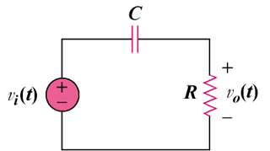

Figure 14.68
For Prob. 14.1.

